Shefa' Alhendi
UI/UX Designer | Front-End & Mobile Developer
 +962 787980339 |  shefaalhendi@gmail.com |  Shefa-atef |  Shefaa-atef | 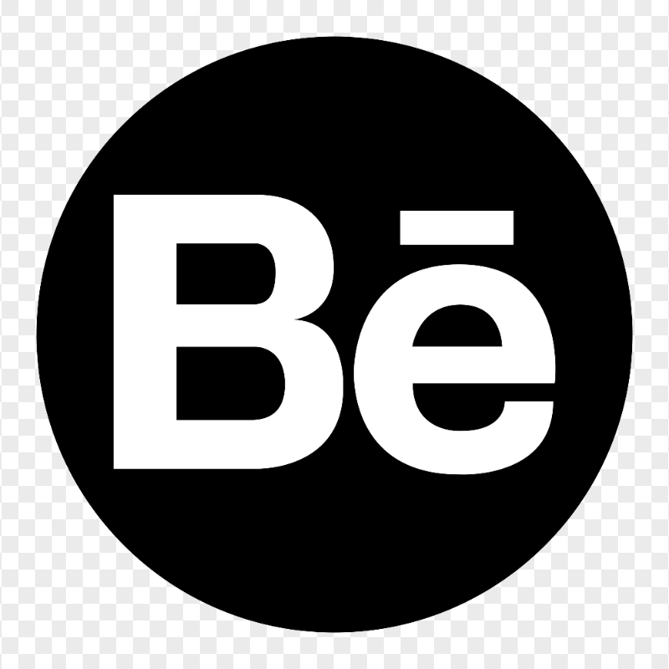 shefaalhindi | portfolio

PROFILE
Computer Science graduate with experience in Flutter, React, UI/UX, and software testing. Skilled in turning requirements and Figma designs into production-ready digital products, with hands-on experience in client communication, testing, and delivery.

EXPERIENCE
Flutter Developer | Quark Software, Amman | Feb 2026 - Present
- Develop Flutter apps using REST APIs, state management, localization, and reusable components.
- Gather requirements, prepare BRDs, coordinate with clients, and test features through release.
Freelance UI/UX & Graphic Designer | Remote | 2022 - Present
- Design responsive websites, apps, dashboards, prototypes, and user flows using Figma.
- Create branding, marketing visuals, and production-ready assets using Adobe Creative Suite.

SELECTED DEVELOPMENT PROJECTS
Tamrat | Smart Fasting Companion | Flutter app + React website | 2026
Google Play | Website
- Built and published a multilingual fasting companion with planning, tracking, prayer-time settings, Supabase auth, and light/dark themes.
- Designed the full UI/UX, branding, and responsive React website.
Zaid | Quran Text Assistant | Flutter app + React website | 2026
Google Play | Website
- Built and published a Quran text assistant with verse search, accessibility-based insertion, favorites, history, RTL, and formatting controls.
- Designed the UI/UX, onboarding, store visuals, and responsive React website.
EcoPals | Graduation Project | Flutter, Firebase, Rive, UI/UX + React website | 2025 - 2026
Google Play | Website
- Built an environmental platform with eco challenges, rewards, rankings, notifications, community features, and an interactive virtual pet.
- Designed the UI/UX and contributed to the responsive React website.
DeepMindset | Adversarial Robust AI Recognition System | Python | 2025
GitHub
- Developed a CNN-based handwritten digit recognition system focused on robustness against adversarial attacks.
- Achieved 99.08% MNIST accuracy and 98.47% adversarial robustness, with preprocessing, model evaluation, adversarial testing, and an interactive Streamlit interface.

SELECTED UI/UX PROJECTS
CareVision Kiosk | Healthcare Kiosk UI/UX — Figma | 2023
- Designed touch-first patient registration, vitals tracking, and accessible kiosk workflows.
Easy Robot Kit | Educational Robotics App — Figma | 2022
- Designed a robotics learning app with block programming, sensor workflows, and controller interfaces.

EDUCATION
B.Sc. Computer Science - Hashemite University | Zarqa, Jordan GPA: 3.87 / 4.00 – Ranked 1st in Class | 2021 - 2025
- Relevant coursework: Data Structures & Algorithms, Mobile App Development, Database Systems, Machine Learning Fundamentals.

CORE SKILLS
Mobile Development | Flutter, Dart, Provider, MVVM, Dio, REST API Integration, Firebase, Supabase, Localization
UI/UX & Product Design | Figma, Wireframing, User Flows, Interactive Prototypes, Design Systems, Responsive Design, RTL Design, Usability, High-Fidelity UI
Front-End Development | HTML, CSS, JavaScript, React, Responsive Web Development, REST APIs, Git, GitHub
Programming & CS | Java, Python, C++, SQL, OOP, Data Structures & Algorithms, Machine Learning Fundamentals, Data Analysis
Visual Design | Adobe Illustrator, Photoshop, InDesign, Premiere Pro, Branding, Illustration, Social Media Design
Testing & Product Delivery | Functional Testing, Regression Testing, Device Testing, Bug Reporting & Verification, Requirements Gathering, BRDs, Client Meetings, Workflow Analysis

AWARDS
First Place — Nahnu Youth Innovation Hackathon, Water Conservation Track | 2026
- Won first place in a national innovation hackathon focused on water conservation and waste-management challenges, contributing to product ideation, UI/UX design, and technical development.
Finalist — Samsung Solve for Tomorrow | 2019
- Selected as a finalist for designing and developing a technology-based plant-health solution in Samsung’s innovation competition.
Top 10 — Zarqa Green Projects Hackathon / IRADA | 2024
- Selected among the top 10 projects out of 138 entries for designing and developing an eco-focused application that encourages environmentally responsible activities through digital engagement and motivation.

CERTIFICATIONS & TRAINING
- Artificial Intelligence — Samsung Innovation Campus
- Flutter & Dart — Academind / Udemy
- Python Training — STEAM Center & ZINC

LEADERSHIP & COMMUNITY
- OSBOHA180 — Graphic Designer, Video Editor & Team Leader; contributed to visual content production and team coordination.
- Google Developer Student Clubs (GDSC) — Speaker & Designer; contributed to technical community events, presentations, and visual content.
- Shoman Ambassador — Public Speaker; participated in community and educational initiatives.

LANGUAGES
Arabic — Native | English — Fluent

